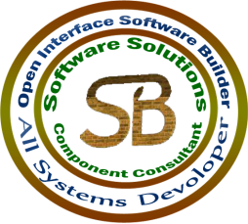
Open Interface Software Builder
Courses & Training Programs
Multimedia:
Course | Duration
1.Photoshop | 1 Month(16 hours)
2.Flash Max | 2 Month(32 hours)
3.Video Editor | 2 Weeks(8 hours)
4.Sound Editor | 2 Weeks(8 hours)
Programming Languages:
Course | Duration
1.C# | 6 Months(96 hours)
2.Vb.net | 4 Months(64 hours)
3.C,C++ | 4 Months(64 hours)
4.Java | 6 Months(96 hours)
5.PHP | 6 Months(96 hours)
6. Android | 4 Months(64 hours)
Website Design:
Course | Duration
1.ASP.Net | 6 Months(96 hours)
2.HTML | 2 Months(32 hours)
3.Java Script | 2 Months(32 hours)
4.Wordpress | 2 Months(32 hours)
Database Programs:
Course | Duration
1.MS SQL Server | 1 Month(16 hours)
2.MS Access | 1 Month(16 hours)
3.Mysql | 1 Month(16 hours)
4.Oracle | 2 Months(32 hours)
Networking:
Course | Duration
1.Basic Networking | 2 Months(32 hours)
2.Advanced Networking | 2 Months(32 hours)
3. Wireless | 1 Months(16 hours)
Assistant Programs:
Course | Duration
1.MS Office | 3 Months(48 hours)
2.Hardware | 2Months(32 hours)
3.SPSS | 2 Weeks(20 hours)
4.Windows Maintenance | 2 Weeks(10 hours)
5.Drivers | 1 Week(5 hours)
6.Other Programs | 1 – 4 Weeks

